Article for Website:
“Nurses Notes”

Is it Coronavirus or Allergies?
With social distancing being so important, one of the things we all can do is go outside and enjoy the nice fall weather. But for students with seasonal allergies, this activity can make them miserable.
Fall allergy triggers are different, but they can cause just as many symptoms as spring allergies. Did you know that fall and winter are the worst times for asthma students too? The biggest triggers for fall allergies are ragweed, mold, dust mites. Ragweed is the biggest allergy trigger, starting in August and lasting well into October. Mold spores love damp wet spots outside, like piles of damp leaves. Dust mites can get stirred in the air when home heat is turned on.
So how can you tell if a student’s cough, shortness of breath, fatigue, headache, sore throat, or congestion is allergies or COVID-19? While they share symptoms, COVID-19 can cause a fever, and fever is not a common symptoms of fall allergies.
The image here from the CDC compares allergy and COVID-19 symptoms:
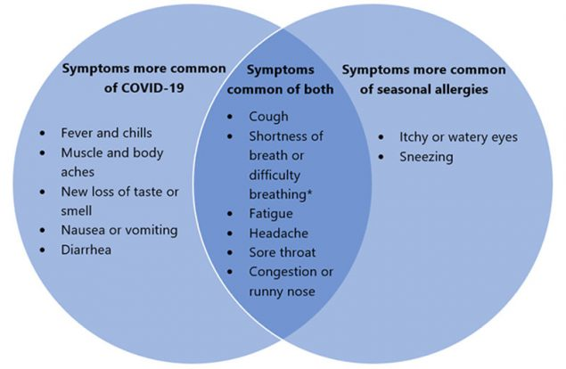
Seasonal allergies may cause shortness of breath in children with asthma that is triggered by allergies.
Because many of the symptoms in both illnesses are similar, it may be difficult to tell the difference between them, and a COVID-19 test may be recommended by your pediatrician to confirm the diagnosis. A student could have both COVID-19 and seasonal allergies at the same time. Very confusing!
There is not enough data to know if seasonal allergies can put someone at higher risk of COVID-19.
The CDC recommends wearing masks to slow the spread of COVID-19, and they may offer limited protection against seasonal allergies. It’s important that children with allergies should wash their masks after each use because the outside covering may carry allergy particles.

Of course, your medical provider is your best person to determine the difference and treat appropriately. Students should stay home if not feeling well. Even more important to wear your mask properly and “WEAR-WAIT-WASH!”

Sources: www.cdc.gov
www.webmd.com
www.umms.org

Mrs. Abruzino, School Nurse

